

Princess Sumaya University for Technology

King Abdullah II Faculty of Engineering

Embedded Systems and Microprocessors (22442)

**Autonomous Pinball Machine**

Students:

|  |  |  |  |
| --- | --- | --- | --- |
| Saleh Huneidi | 20200474 | NIS Engineering | [sal20200474@std.psut.edu.jo](mailto:sal20200474@std.psut.edu.jo) |
| Nour Darwazeh | 20200139 | NIS Engineering | [nou20200139@std.psut.edu.jo](mailto:nou20200139@std.psut.edu.jo) |
| Mohammad Alsaadi | 20200148 | NIS Engineering | [moh20200148@std.psut.edu.jo](mailto:moh20200148@std.psut.edu.jo) |

*Introduction*

Pinball is an arcade game in which a ball is fired into a specially designed cabinet known as a pinball machine, hitting various lights, bumpers, ramps, and other targets depending on its design. The game's object is generally to score as many points as possible by hitting these targets and making various shots with flippers before the ball is lost. Most pinball machines use one ball per turn, and the game ends when the ball from the last turn is lost.

Our project is based on designing an autonomous pinball machine, in which integrated sensors, actuators and other components would cause the machine to play on its own, and hence, providing an entertaining scene to the viewer and introducing a modern, developed version of this arcade game.

*Proposed Idea*

Our team proposes building an automated pinball machine that plays on its own to achieve a high score. The machine will have two arm handles that move using DC motors to hit the ball. There will be three obstacles on the playing field, each equipped with IR sensors that increase the score every time the ball hits them from below. Additionally, ultrasonic sensors will cause the arm handles to start oscillating when the ball approaches, and an LCD screen will display the score and "Game Over" when the ball goes down the middle. This machine will provide a fun and challenging experience for onlookers and is an excellent addition to any arcade or game room.

*Block Diagram*

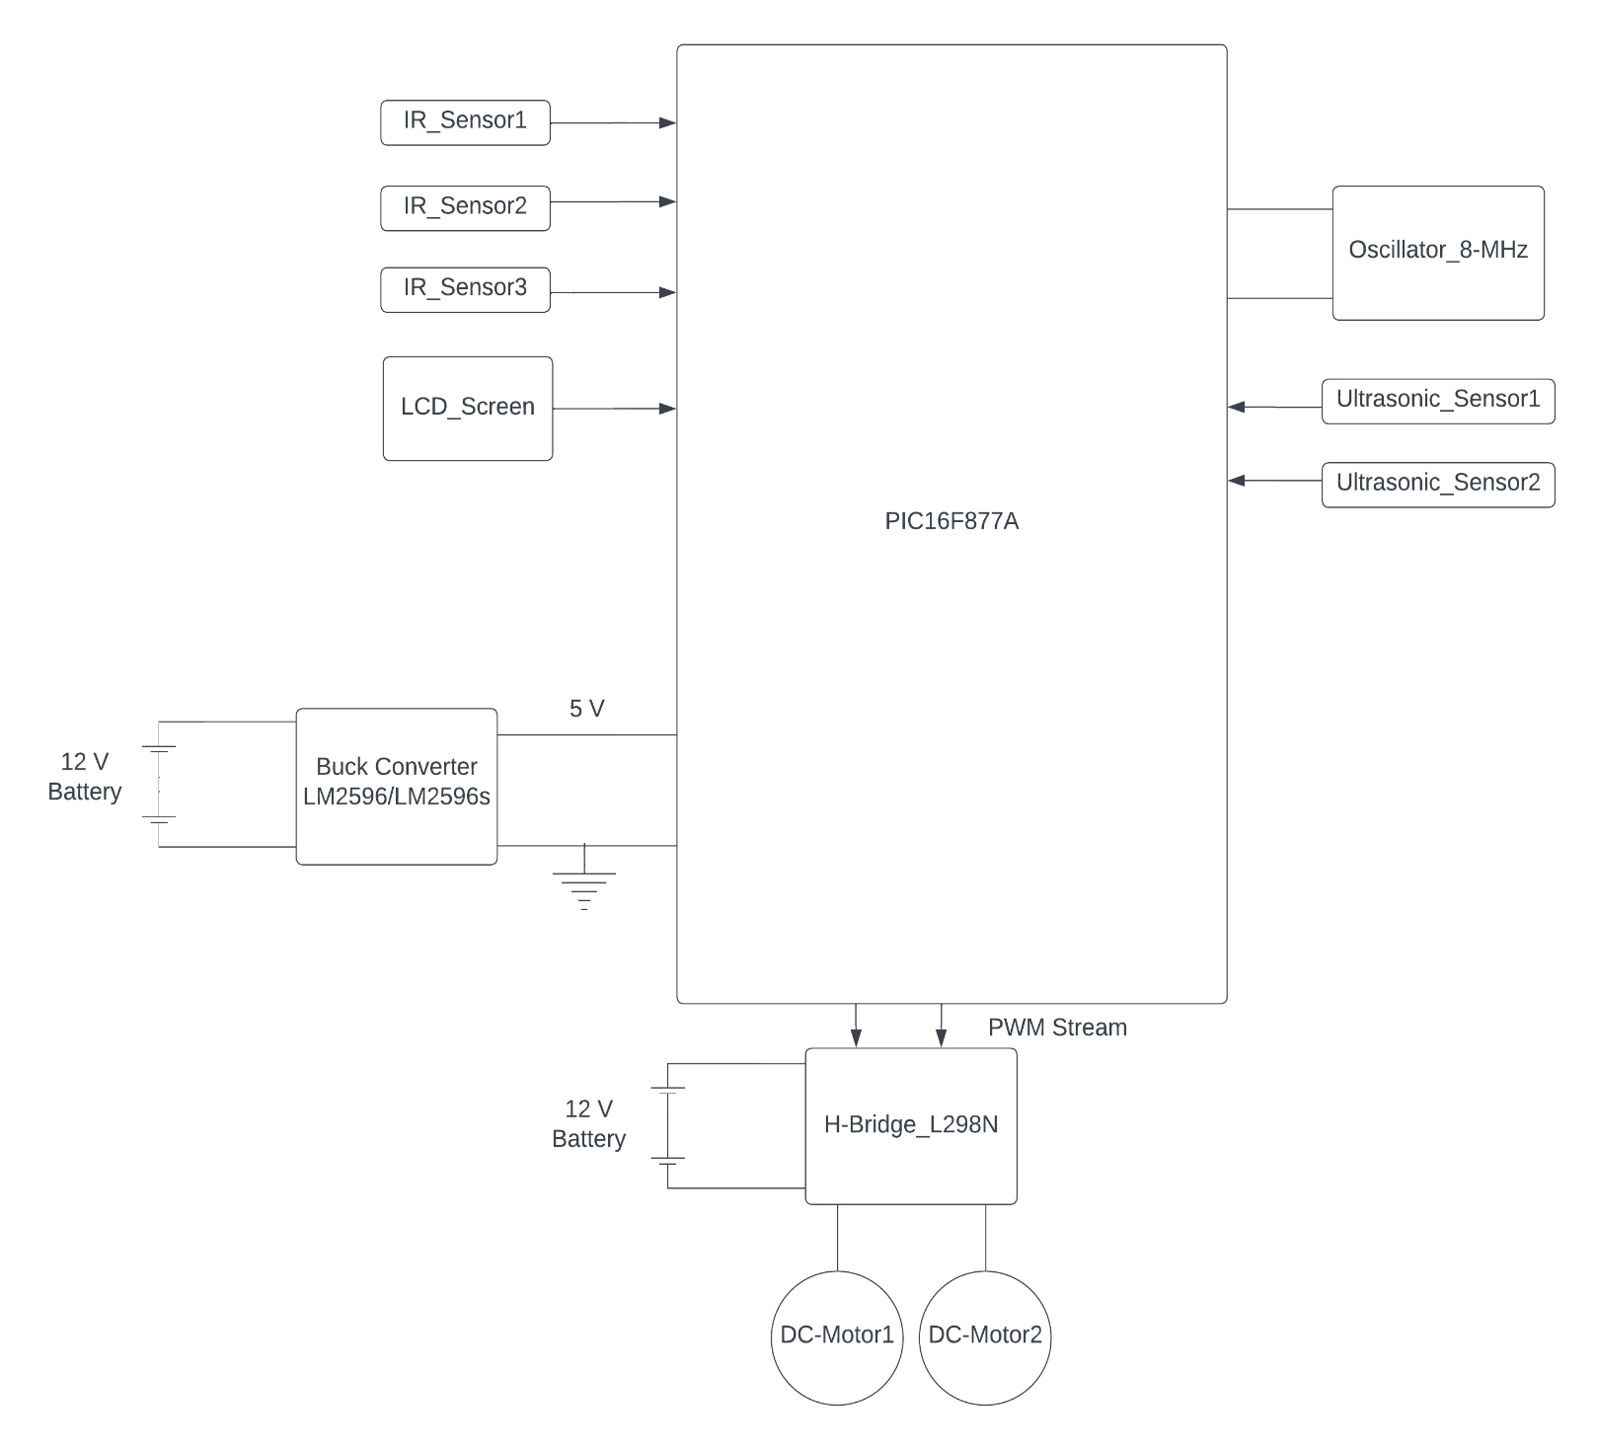*Required Components and Expected Costs*

|  |  |  |
| --- | --- | --- |
| Items | Quantity | Price (JDs) |
| PIC16F877A | 2 | 15 JDs |
| DC-Motor type 130/Servo Motor | 2 | 0.9 JDs/5 JDs |
| H-Bridges L298N | 1 | 4.9 JDs |
| Buck Converter LM2596/LM2596s | 1 | 1.95 - 2.95 JDs |
| IR Sensor | 3 | 4.35 JDs |
| Ultrasonic Sensor HC-SR04 | 2 | 5 JDs |
| LCD 16x4 Screen | 1 | 7 JDs |
| Wires (M-M, F-M) | 80 | 6 JDs |
| Breadboard | 1 - 2 | 15 - 18 JDs |
| Oscillator 8 MHz | 2 | 1 JD |
| Others | - | 15 JDs |
| Total Expected Cost | | 76.1 - 85.1 JDs |